Marine Biology
Señor Robles

Aquatic Bird Table

Step Four: Do some online birdwatching to fill in the final column. Directions on the website.

# Name Picture Recognition characteristics Virtual birdwatching
1. | American Dipper | 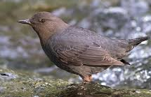 |  | https://www.youtube.com/watch?v=HyFEbuy8RUg  This is the only aquatic songbird. It coats its feathers with oil to be buoyant. Walks underwater.
2. | Avocet
3. | Black skimmer
4. | Blue-footed booby
5. | Common loon/Diver
6. | Dowitcher
7. | Galápagos penguin
8. | Glaucous-winged gull
9. | Great blue heron
10. | Hooded merganser
11. | Horned puffin
12 | Magnificent frigatebird
13. | Pelagic cormorant
14. | Razorbill
15. | Roseate spoonbill
16. | Storm petrel
17. | Wandering albatross
18. | Western grebe
19. | Western sandpiper
20. | Wrybill
21. | Snowy egret | 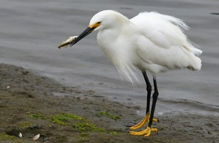 | - Pure white plumage  - Black stilt legs with yellow feet  - Long black spear-like beak
22.
23.
24.
25.
26.

