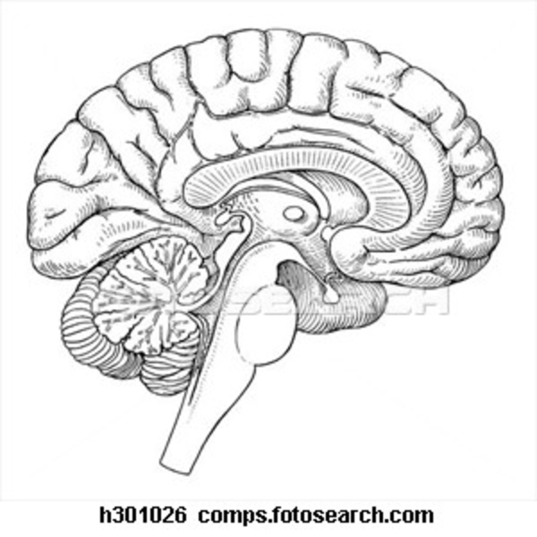
Biomedical Science
Señor Robles
Intro to the Brain
Structure & Function

Part One: Do some online research to identify regions or lobes of the brain.
Fill in the left column with which brain component is mostly responsible for the functions listed on the right.

1. |  | Regulates sleep, hunger, thirst, body temperature, blood pressure, and fluid level to maintain homeostasis
2. |  | Lobe responsible for speech production, concentration, problem solving, planning, and voluntary muscle control, personality
3. |  | Lobe for vision, recognizing objects visually, and combining images received visually
4. |  | Lobe for general interpretation area, understanding speech, ability to use words, and sensations including heat/cold, pressure, touch, and pain
5. |  | Responsible for involuntary functions such as breathing and the beating of your heart, also for blood pressure, and automatic reactions such as coughing, vomiting, sneezing, and swallowing
6. |  | Transfers sensations collected from the body (except olfaction) and relays them to the cerebrum
7. |  | Lobe for interpretation of sensations, remembering visually, remembering through sounds, speech and hearing
8. |  | Joins the cerebellum to the cerebral hemispheres, responds to information collected from the eyes and ears
9. |  | A relay station for information coming from the spinal cord to the cerebrum, or between the cerebrum and the cerebellum
10. |  | Coordinates skeletal muscle movements, making them smooth and graceful, responsible for posture, balance, and general coordination
11. |  | The highest control center of conscious action

Part Two: External Brain Geography
Label all the brain parts for both diagrams.

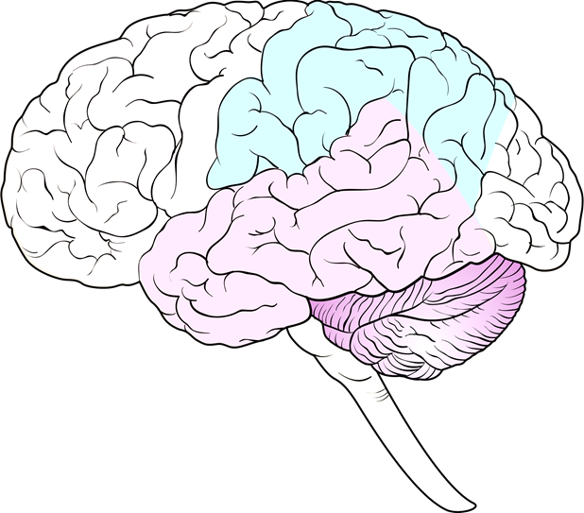
A. The three major brain regions

B. The subdivisions of the cerebral cortex

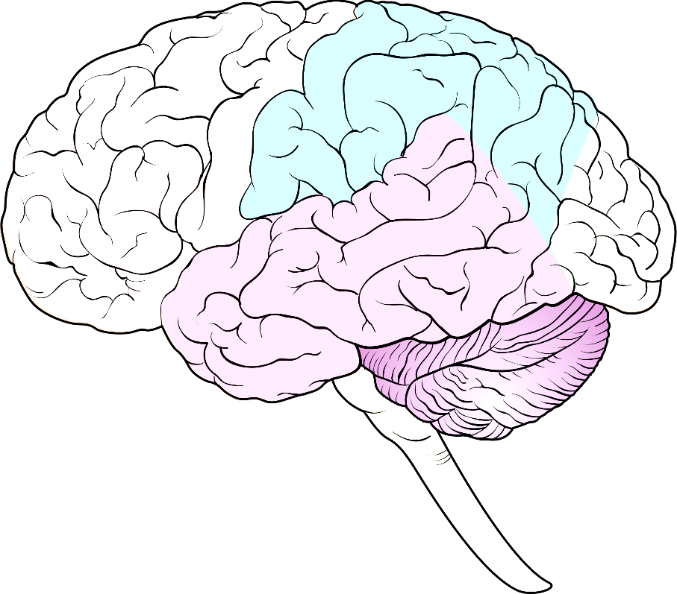

Part Three: Internal Anatomy
For the image below, label the parts and color code major regions.
Create a color key below.

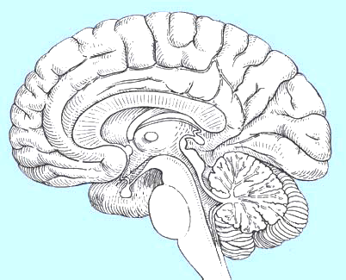

Color Key

