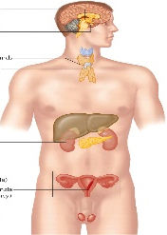
Biomedical Science
Señor Robles
Journey through the Endocrine System

Start by going to this website: http://www.hormone.org/hormones-and-health/the-endocrine-system

Part One: Take the Tour Go through each of the sections of the tour. Play the Narration and read along to get all the information to answer the following questions.
Overview
1. What are seven functions of the endocrine system?

a. d. g.

b. e.

c. f.

Hypothalamus
2. How is it that this part of the brain is part of the endocrine system? (What does it do?)

Pineal gland
3. What hormone does this gland secrete? What function does this hormone perform?
a.

b.

Pituitary gland
4. Based on the description, explain what makes this gland such an important component of the endocrine system:

Thyroid gland
5. What is the main function of this gland? What are the two hormones it secretes? (check your notes)

a.

b. ____________________________ and ______________________________

Parathyroid glands
6. Where exactly are these little guys located? What is their role?

a.

b.

Thymus
7. What makes this gland different from the rest? Describe its role and the change it makes.

Pancreas
8. What major hormone does this organ/gland secrete, and what does that hormone do?

Adrenal glands
9. Where are these glands located? Describe their main secretion.

Ovaries
10. What are the two hormones released here? What other function do these glands perform?

a. ______________________ and ________________________

b.

What gland is stunningly omitted from this tour?

Part Two: Name that Gland
On the sidebar, click on Endocrine Glands and Types of Hormones to find which glands perform the following. After each function, name the gland (no repeats).

1. Helps distribute stored fat:

2. Secretes “humoral factors” which aid in the development of a healthy immune system:

3. Maintains a healthy blood sugar level:

4. Like a general in charge of a colonel, this gland uses the hormone “Growth hormone-releasing hormone” (GHRH)
to provoke the pituitary gland into releasing its growth hormone:

5. Aside from the male reproductive functions, these glands maintain a healthy level of muscle and bone mass:

6. Controls calcium and phosphorus levels in the body which aids in bone development:

7. Maintains menstrual periods in women:

8. Helps your body recognize when it’s time to go to sleep:

9. Controls metabolism, including the use of energy and the consumption of oxygen:

10. Like a colonel in charge of a lieutenant, this gland sends Thyroid-stimulating hormone (TSH) down to the
thyroid to keep it on task.

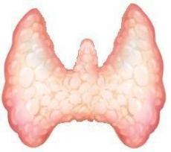
Part Three Label the Picture
Alongside each image, name the gland being pictured (10 total):
