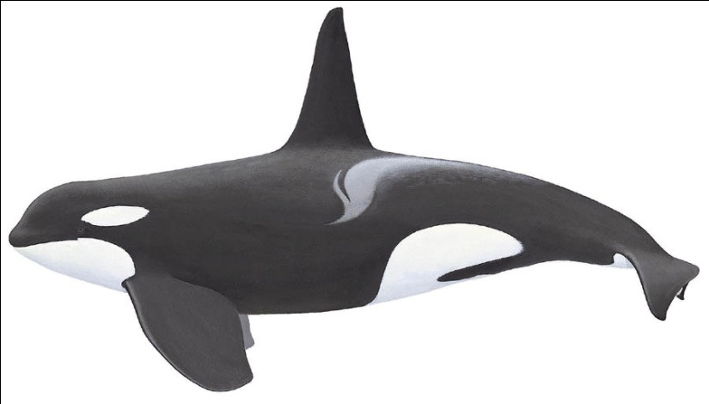Marine Biology Name:

Señor Robles

Period:

**Welcome to Marine Biology**

Syllabus 2019-2020

Contact Information

* Room 1301
* Email: [roblesb@issaquah.wednet.edu](mailto:roblesb@issaquah.wednet.edu)
* Website: <http://theroblesite.weebly.com>
* (425) 837-6063

CLASS OBJECTIVES

* To develop Ocean Literacy
* To expand your scientific knowledge into the specific realm of marine life

COURSE OUTLINE

Below are the units we cover. The order is subject to change and does not conform to the order of units presented in the textbook.

First Semester

**1. Aquatic Insects**

Arthropod anatomy, Classification of living things, Adaptations to an aquatic lifestyle

**2. Watershed Habitats**

Human management and impact on the environment, Biomagnification, Edge Ecosystems

**3. Migratory Fish**

Life cycles and life histories, Walking field trip to the Issaquah Hatchery

**4. Salinity**

Adapting to salty conditions, Osmoregulation, Hypersaline conditions to raise specialized organisms

**5. Fish**

Special adaptations, Classification, 50 + species to learn! Dissection of bony fish and sharks

Second Semester

**1. Returning to the Sea**

Land vertebrates, including reptiles, birds, and mammals, that have adapted to living in the ocean

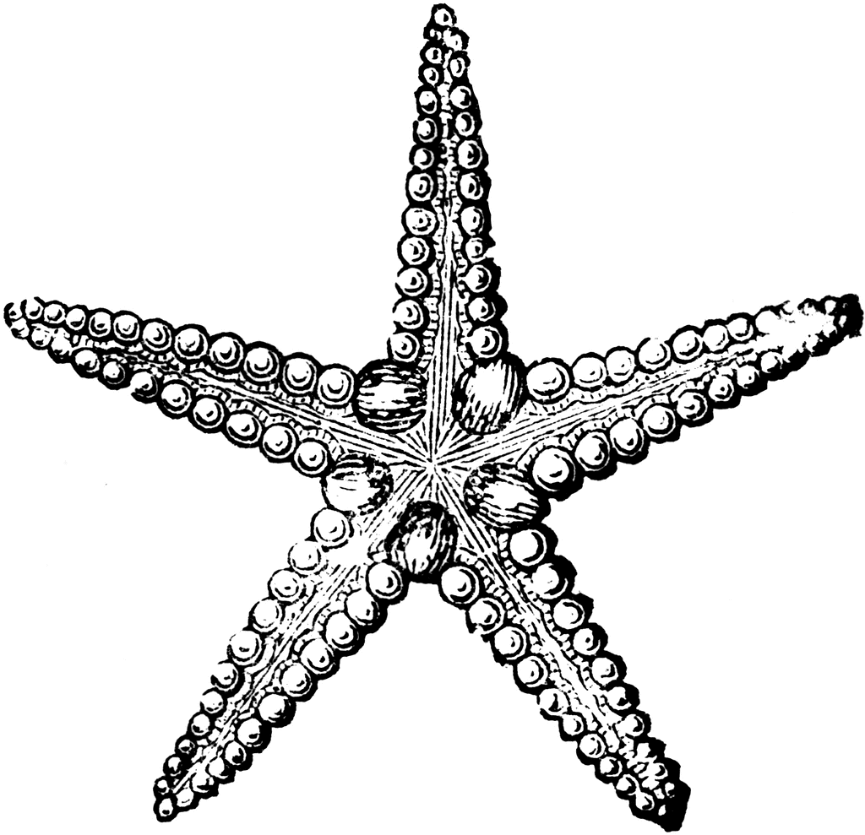

**2. Oceanography**

Physical forces of the ocean: tides and currents, Marine geography, Nautical exploration

**3. Seaweed & Plankton**

The basis of the marine food web, The world of larvae

**4. Marine Invertebrates**

Anatomical investigations of invertebrates, field trip to the Seattle Aquarium

**5. Human Impacts on the Ocean and its Life**

Numerous issues of marine environmental degradation, Captivity of marine mammals

CLASSROOM EXPECTATIONS

I am only allowed for educational purposes and with permission.

* Treat all class members (including the instructor) with respect
* 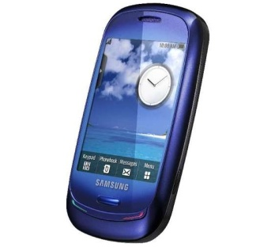Keep the room clean.
* Be aware of all the safety rules, and conduct yourself accordingly. Goggles are required.
* Cell phones are to be parked at the beginning of each period.
* There are times you may use your phone for taking pictures or for going online, but you need to get permission.
* Please be on time. More than three tardies per semester will earn you detention.
* Be aware of the late work policy:

___If you are absent and can’t help turning something in past its due date, write “ABSENT” on

the paper, along with the date you were missing.

___Late work (not due to absence) is worth 50%

* Come to class prepared
  + Pencils & pens
  + Paper in a binder
  + Lab journal (bring everyday)
  + You may usually keep your book at home.

## Grading Scale in %

**Percentage breakdown**

Quizzes & tests….………50

Labs…..……….....……...20

Collaborative Projects…..10

Semester Final………..…10

Homework………….…….5

Participation……………...5

A 93 or higher

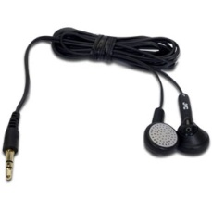

Sorry,I am ONLY allowed after the final.

A- 90-92.99

B+ 87-89.99

B 83-86.99

B- 80-82.99

C+ 77-79.99

C 73-76.99

C- 70-72.99

D+ 67-69.99

D 60-66.99

F 0-59.99

Some things to know:

* Regular class assignments are graded and recorded, but do not factor into your letter grade.
* Class assignment and homework grades are simply 1-3 (3 being complete, correct, and on time.)
* Collaborative projects are typically one per quarter; we change groups each quarter.
* Pop quizzes are offered on a regular basis to keep you on your toes
* Participation points (10/quarter) if you engage in class discussions, answer questions reasonably
* Loss of participation points is rare, but happens occasionally with poor choices of behavior
* Cheating/copying is dealt with in ways consistent with the guidelines of the Student Handbook
* Walking field trips require chaperones; could your parent help?

Please provide signatures below, and return this sheet to me intact (don’t cut out this box):

Student: _______________________________________

Parent/guardian: _________________________________ Date: ________________

□ Yes, I would love to volunteer to chaperone a walking field trip!