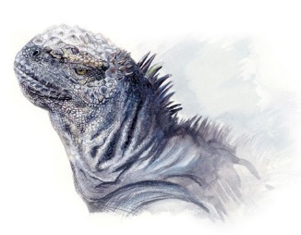
Marine Biology
Señor Robles
Marine Iguanas

1. What makes the marine iguana unique among the world’s lizards?

2. Where does it live, and why doesn’t it live in other similar areas around the world?

a.

b.

3. What’s on the menu for a marine iguana? Fish? Halobates?

4. How does being ectothermic affect the feeding routine of a marine iguana?

5. Describe the sexual dimorphism that’s evident in a colony of marine iguanas:

Physical:

Social:

6. What is the geologic nature of the Galápagos Islands (okay, so now you can answer 2a)? How and when were these islands
formed?

a.

b.

7. When is the best time of year for marine iguanas to lay their eggs?

8. Describe at least four adaptations these lizards have to their marine lifestyle on volcanic islands:

a.

b.

c.

d.

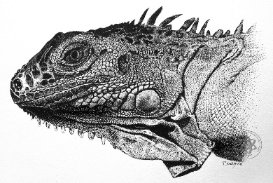
Hint for one feature: Compare the profile of the South American tree iguana on the left with the marine iguana on the right.
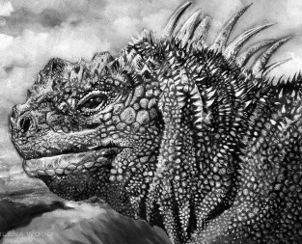

9. Compare and contrast the marine iguana and the Galápagos sea lion in terms of their ocean excursions.

Critter | How long they can stay out in the water | How long they can stay UNDER water
Marine Iguana
Galápagos Sea Lion

10. The Galápagos is almost directly on the equator. Isn’t the water always warm?

11. Describe the commensal relationship the marine iguana has with a little wrasse.

12. What’s with the snot rocket?

13. Where else, besides the Galápagos, can you find wild marine iguanas?

14. Where did these unique animals come from? What’s the best hypothesis?

15. You may have noticed that neither the marine iguanas nor the land iguanas are vocal. So how do they “talk” with each
other? Explain with a drawing.

