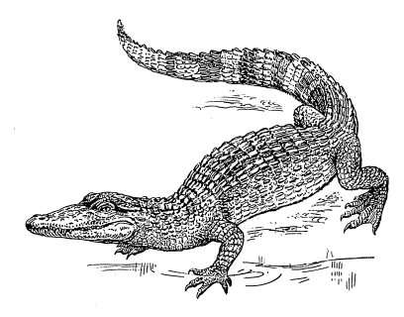
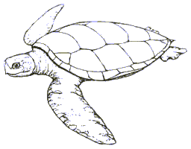
Marine Biology
___
20
Señor Robles
Marine Reptiles Quiz

Part One: (10 points) Multiple choice
1. Which of the following were dinosaurs?
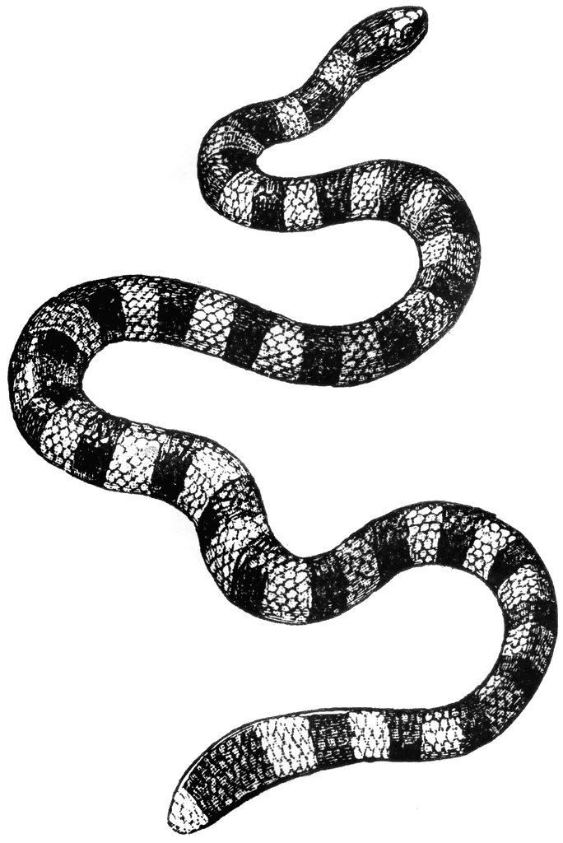
a. Mosasaurs b. Plesiosaurs c. Ichthyosaurs d. none of these

2. Regarding metabolism and body temperature, which TWO terms apply to reptiles?
a. Endothermic b. Exothermic c. Ectothermic d. Poikilothermic

3. The nictitating membrane is useful for protecting this body part:
a. eyes b. ears c. mouth d. fingers

4. An indication that sea turtles evolved from land-living ancestors is the presence of:
a. Flipper-like limbs
b. A hard shell
c. The toothless beak-like mouth
d. The one or two (or none) little claws on their flippers
___
10

5. The only marine reptiles that are ovoviviparous are the:
a. marine iguanas b. saltwater crocodiles c. true sea snakes d. sea turtles

6. Sea turtle eggs show temperature-dependent sex determination. This USUALLY means that:
a. Eggs hatched in cooler conditions are mostly female b. Eggs hatched in warmer conditions are mostly male
c. Every clutch of eggs is 50:50 male to female d. Half of the hatchlings change their sex as they mature

7. The only reptiles that don’t swim with lateral undulations are the:
a. lizards b. crocodilians c. snakes d. turtles

8. What special sense organ does a sea snake have that enables it to smell underwater?
a. Thompson’s organ b. Jacobson’s organ c. Jefferson’s organ d. Franklin’s organ

9. Yuck, who wants to eat a living sea sponge? This sea turtle does:
a. Loggerhead b. Green c. Leatherback d. Hawksbill

10. The only marine reptiles to be strictly herbivorous belong to this group:
a. lizards b. crocodilians c. snakes d. turtles

Part Two: (10 points)
Write each number ONCE, and in its appropriate section of the triple Venn diagram.
Yes, some sections will end up with more than one number (and one will not have any!)

1. A marine reptile of the Mesozoic era (but NOT a dinosaur)
2. Used a fishlike caudal fin for propulsion
3. Discovered by Mary Anning
4. Used paddle-like limbs for propulsion
5. Evolved from terrestrial lizards sometime in the Mesozoic era
6. Used a laterally flattened (but not fishlike) tail for propulsion
7. Known from fossil evidence to be ovoviviparous
8. Numerous genera that, over time, grew longer and longer necks
9. Occupied the “dolphin niche” of its time
10. Fossil skull evidence of an extra set of teeth on the roof of the mouth

ICHTHYOSAUR

___
10

PLESIOSAUR MOSASAUR

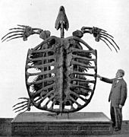
Extra point:

Name this other massive Mesozoic marine reptile:
___
1

