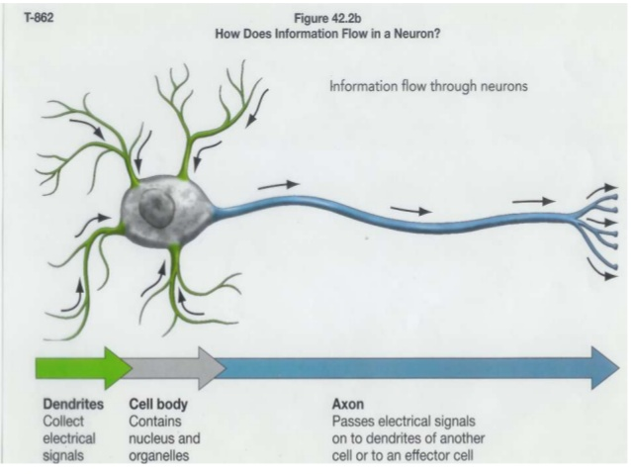
Biomedical Science
Señor Robles

Nerve Impulse Transmission
An Introduction
Part One: some basics

1. Why is an inactive nerve cell considered polarized?

2. What is the resting potential, and how do you think it got that name?

3. What type of molecule is the sodium-potassium pump?

4. What is the role of the sodium-potassium pump?

5. Why is the electrical charge outside a nerve cell a positive charge?

6. What is an action potential?

Part Two: The Neuron’s Membrane
Draw a section of the axon’s membrane that displays the three types of transmembrane proteins associated with the action potential. Label them, color them, and include the ions they deal with.
Find your own website for your reference.

Part Three: Yes! An actual electrical impulse
Label the parts (don’t worry about the missing numbers 1-4)

