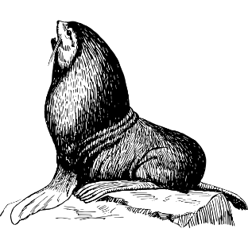
Marine Biology
Señor Robles

Know your Pinnipeds

KINGDOM ANIMALIA-Phylum ChordataSubphylum VertebrataClass Mammalia Order CarnivoraSuborder Pinnipedia
Family name | Otariidae (eared seals) | Phocidae (true seals)
Common names of examples from each family
Characteristics of the family

Drawing (that YOU do) of an example from this family

Who is missing? There is one more pinniped that is the sole member of a third family. Figure that out, and fill out the back page.

Family name | …idae
Common name of only example from this family
Characteristics of the family
Drawing (that YOU do)

