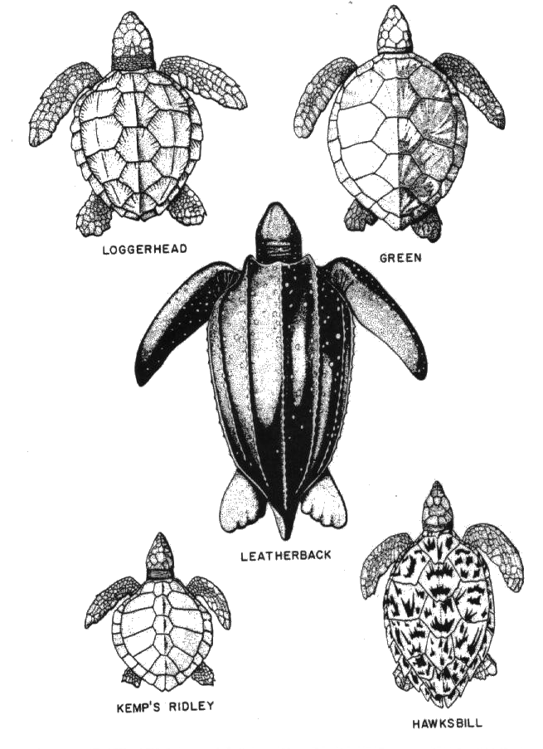
Marine Biology
Señor Robles
Identify that Sea Turtle Species

