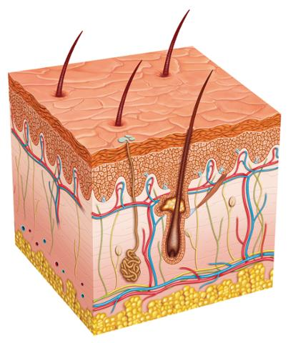
Biomed
Señor Robles

Components of Human Skin

Part One: After each description, identify which component of the skin it is.

1. Rounded structure at the base of a hair. It receives blood flow and allows growth of the hair:_________ ___________

2. Composed of keratinocytes, this is the uppermost subdivision of the epidermis: __________ ______________

3. Found alongside the root of a hair are these structures that secrete oil: ____________________ ___________

4. Meaning “below the skin”, this layer is filled with subcutaneous adipose tissue: ____________________.

5. This tiny muscle causes your hairs to stand up when you get “goose bumps.” ____________ ___________.

6. A.K.A. the tactile corpuscle, this sensory receptor is located close to the surface of the skin: _______________ ____________.

7. The middle skin layer, which contains collagen and various skin components: __________________.

8. This sensory receptor, named by an Italian scientist, is located deep in the dermis and detects pressure: ____________ __________.

9. The uppermost skin layer, composed of layers of dead flattened skin cells: _______________________.

10. These wavy ridges are found at the boundary of the dermis and the epidermis: ________________ ________________.

11. Openings on the surface of your skin where sweat emerges: ______________________________________.

12. The lowest layer of the epidermis, composed of living cells that still divide: ________________ __________________.

13. Also found deep in the epidermis are these pigment-containing cells, giving you a tan in the summer: ______________________.

14. A fancy name for “sweat gland”: __________________________ ________________.

15. Yet another sensory receptor named after an Italian scientist, it detects pressure and touch: __________________ ____________.

Part Two: Make sure each structure listed above is depicted on the drawing you made. You might have to add a side
drawing for the subdivisions of the epidermis.

